

Practice Development Plan Pilot

Evaluation Report

Participant Summary: November 2008

Claire Tochel, Linda Young, Heather Cassie and Jan Clarkson
on behalf of the PDP Evaluation Group

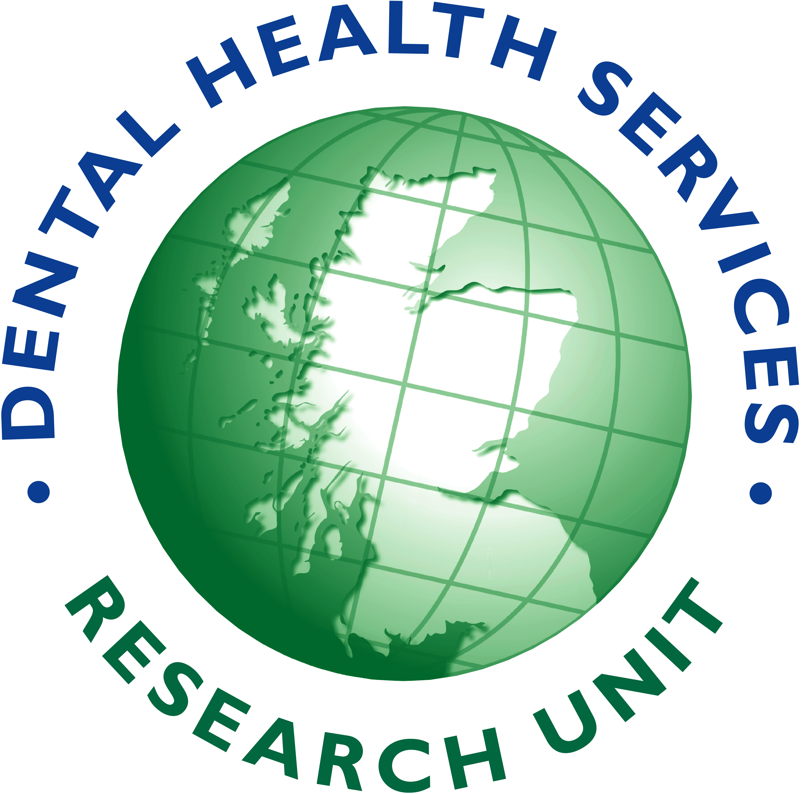

BACKGROUND

Responding to the Dental Action Plan Initiative (SEHD 2005) a brief was given to the Regional Dental Postgraduate Centres in Scotland to implement practice development plans (PDP). A pilot phase ran between May and October 2007.

The aims of the PDP pilot were to:

- provide General Dental Practices with a development product and process, both of which are sustainable, effective and efficient;
- promote quality improvement within General Dental Practices by encouraging practice members to identify and undertake training, based on explicit identified needs.

To achieve this aim participating practices were expected to be able to:

- demonstrate a structured, focused and educationally defensible approach to identifying learning needs;
- access quality training based on specific learning needs and obtain protected learning time where appropriate;
- use the online support and learning tools;
- identify areas in need of quality improvement within their practice as a result of engaging in PDP.

AIMS AND OBJECTIVES
The scope of the evaluation was informed by the aims and objectives of the pilot project. The aims were to:

- evaluate the implementation of the PDP pilot framework in General Dental Practice;
- inform the future development and implementation of PDP in General Dental Practice.

The objectives were to:

- evaluate if the pilot framework for PDP supported practice teams
a. identify learning objectives specific to the needs of
  - the practice’s development;
  - the individual’s personal development;
b. identify appropriate training based on learning needs;
c. access appropriate training based on learning needs;
- evaluate the utility of the online support tool for the implementation of PDP in general practice;
- evaluate attitudes and beliefs towards practice and individual development;
- identify the barriers and facilitators to the implementation of PDP from the perspective of
  - the practice teams;
  - the PDP implementation teams.

PARTICIPANTS
All members of the dental team in 37 participating practices (this number reduced to 36 during the pilot) were invited to take part. Among the 372 dental team members there were five categories of professional groups: dentists, nurses, hygienists, receptionists and managers (Figure 1). PDP Tutors and members of the working group tasked with implementing PDP in the individual regions were also invited to take part in the evaluation.

Figure 1

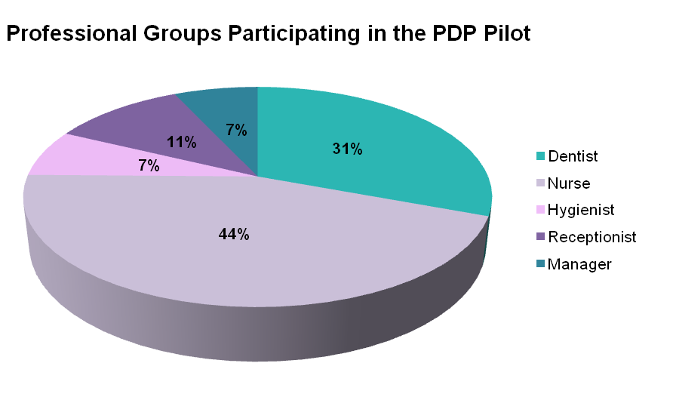

METHODS
The evaluation team undertook several evidence gathering exercises. These included postal questionnaires, gathering online information, telephone interviews with practice team members, focus groups with PDP participants and tutors and face-to-face interviews with the PDP implementation team.

RESULTS
Postal Questionnaires:
Questionnaires were returned by dental team members in all of the practices that were taking part in the PDP pilot. Two-hundred and fifty-four dental team members returned the beginning of pilot questionnaire giving a response rate of 68%. The end of the pilot questionnaire was returned by 216 dental team members (58%).

Questionnaire data revealed an increase in the percentage of dental team members who agreed that their practice held regular, structured practice meetings from the beginning to the end of the pilot. The majority reported that they usually attend these meetings and think that the meetings are useful and important. A comparison of the responses from dentists with the responses from non-dentists indicates that dentists think regular, structured practice meetings are significantly more useful than non-dentists.

There was also an increase in the reported use of PDP’s from the beginning to the end of the pilot. At the end of the pilot in 33 of the 36 pilot practices at least one member of practice staff reported having a PDP. End of pilot responses by region are presented in figure 2.

Figure 2

Percent of Total

56
31
13
77
11
11
52
19
29
56
7
37
64
20
16
68
10
23
0
10
20
30
40
50
60
70
80
90
yes
no
not sure
yes
no
not sure
East & North-East
South-East
West
Dentists
Non-Dentists
Does your Practice have a Practice Development Plan?

There was evidence that PDP supported the practice teams to identify learning objectives specific to both the practice’s and the individual’s development. There was an increase in the reported use of structured tools to identify these learning needs, in particular, the use of Personal Development Plans which almost doubled (Figure 3) and significant event analysis.

Figure 3

Percent of Total

41
53
6
32
50
18
48
45
7
40
23
37
81
19
0
78
13
9
0
10
20
30
40
50
60
70
80
90
yes
no
not sure
yes
no
not sure
East & North-East
South-East
West
Dentists
Non-Dentists
Do you have a Personal Development Plan?

Online PDP Tool:
Data on practice staffs’ use of the online PDP tool was automatically gathered at each log in. The number of times practice members logged in to the online tool and visited one of the PDP pages during the pilot can be seen in Figure 4. Over a quarter of participants visited the PDP pages at least once, mostly dentists and nurses.

Figure 4

Number
0
5
10
15
20
25
30
35
40
45
<= 2
3 - 5
6 - 10
11 - 50
51+
Visits per person
receptionist
nurse
manager
hygienist
dentist
Number of visits to PDP online tool pages by profession

Telephone Interviews and Focus Groups:
The professional groupings and regional distribution of those who participated in the interviews and focus groups broadly reflected that of the pilot population. Telephone interviews with dental team members were generally positive. The main advantage of using PDP, reported by over two-thirds of interviewees, was the focus on team learning. Others reported that the PDP pilot was well organised and provided good quality training pitched at the right level for all team members.

The focus groups with dental team members and tutors were also positive on the whole. There was a general consensus about the benefits of working together as a team, developing the practice as a whole and how this could have a positive effect on the motivation and enthusiasm of the dental team.

“...a lot of the times when you do things, it’s aimed at the dentists/dental nurses whereas reception was able to get involved as well with what was going on.”

The advantage of being able to access in practice training was frequently mentioned, particularly the consistency of training and improved dissemination of new knowledge and information. It was felt that having training within the practice and encompassing the whole team made it easier for team members to relate the training to their own practice and role. It also motivated team members to take ownership in specific areas. One participant commented:

“I think the good thing is that everybody was there and got told the same thing. Whereas if a dentist goes on a course they get told one thing, then the nurses go and they get told another thing and everybody has their own way of doing it... everyone was told the same thing on the same day so everybody is working now under the same instructions.”

It was however noted that there was a desire for more training and courses to be made available and there was some concern, particularly amongst the non-dentists, about increased administration and the time associated with this. Further barriers to the implementation of PDP were time constraints, funding and difficulties accessing the online support tool. Participants thought that the main success of the pilot was the introduction of PDP tutors, whose role it was felt had been crucial to the successful implementation of PDP.

“the PDP tutors have been a fantastic success”
PDP tutors in all regions agreed that horizontal working and a sense of all practice members working together on the same level, towards a shared goal was key to the success of the pilot. In one region the tutors adopted differing approaches when communicating with their practices; one tutor liaised with only the practice principal, whereas the other communicated with the whole dental team. Although it was noted that finding an appropriate time to speak to the whole team together was more challenging, it was perceived that this approach was beneficial. It was noticeable at the end of pilot ‘debrief’ evening that a significantly higher proportion of non-dentists attended from the practices where communication took place with the whole team:

“I think in our practices involved in the pilot it was teamwork. Everybody working together and they were all seen as equals as well, the dentists and the nurses and the receptionist were all doing exactly the same courses, they seemed to like that.”

SUMMARY
In general, there was widespread support for the continuation of PDP and for its implementation in the wider GDS. Practices participating in the PDP pilot reported that this had been a beneficial experience leading to improvements in practice team working, team development and team awareness. It was also felt that the teams’ motivation and communication had improved as a result. However, there were challenges in terms of time constraints, funding issues and difficulties accessing and using the online PDP support tool.

The PDP Evaluation Team disseminated the full results to the PDP implementation teams from across Scotland in March 2008 including areas of success and suggested improvements from pilot participants.

Acknowledgements
The PDP Evaluation Team would like to thank all PDP practice members, PDP tutors and the PDP working group for this help in this study.

THE PDP EVALUATION TEAM
Jan Clarkson | Principal Investigator, SDPBRN, DHSRU, University of Dundee
Claire Tochel | Research & Information Officer, NES
Linda Young | Research and Development Manager, SDPBRN, NES
Heather Cassie | Research Fellow, SDPBRN, DHSRU, University of Dundee
Debbie Bonetti | Research Fellow, DHSRU, University of Dundee  - questionnaire development
Julie McDonald | Researcher, NES  - focus group facilitation
Gillian Ramsay | SDPBRN, DHSRU, University of Dundee  - administration
Andrea Baker  Amanda McKie | SDPBRN DHSRU, University of Dundee  NES  - telephone interviews

A full copy of the evaluation report can be requested from Heather Cassie
Email: h.cassie@cpse.dundee.ac.uk Tel: (01382) 420061.

© 2008 by Scottish Dental Practice Based Research Network
ISBN 978 1-906117-18-4

Scottish Dental Practice Based Research Network
Mackenzie Building, Kirsty Semple Way, University of Dundee, Dundee DD2 4BF

All rights reserved.
No part of this publication may be reproduced by any means, or transmitted, or translated into a machine language without the written permission of the publisher.

An Action Plan for Improving Oral Health and Modernising NHS Dental Services in Scotland, Scottish Executive, 2005. www.scotland.gov.uk/Resource/Doc/37428/0012526.pdf

